**Introduction to Access Scorecard in your local (No Statistics, No Certification Results dependencies)**

This document explains how to install CCDA Scorecard application in local laptops/desktops.

**Pre-requisites:** Below are list of pre requisites for CCDA Score card application installation.

1. Apache Tomcat Server ( >= 7 version)

Below are the steps to install Score Card application using war file:

**Step 1:** Download .war file by using <https://github.com/siteadmin/Scorecard-Local-Instantiation/blob/master/Version2/scorecard.war> location.

**Step 2:** Copy the war file to Apache tomcat WEBAPPS folder.

**Step 3:** Start tomcat server, use [http://localhost:<tomcat](http://localhost:%3ctomcat) port number>/scorecard URL to access CCDA scorecard application.

**Follow below mentioned steps if you want to create scorecard war file by using source code.**

**Step1:** Download source code by using <https://github.com/siteadmin/CCDA-Score-CARD> Location. (Please download source code from master branch).

**Step 2:** Delete org.sitenv.service.ccda.smartscorecard.repositories.postgres package.

**Step 3:** Delete ScoreCardStatisticProcessor.java under org.sitenv.service.ccda.smartscorecard.processor package.

**Step 4:** In CcdaSmartScorecardController.java delete line numbers 24, 81, 82, 118, 119 and 120.

**Step 5:** Delete package org.sitenv.service.ccda.smartscorecard.entities.postgres.

**Step 6:** Delete PersistanceConfigurationPostGres.java under org.sitenv.service.ccda.smartscorecard.cofiguration package.

**Step 7:** Delete “,PersistanceConfigurationPostGres.class” in line number 12.

**Step 8**: Commented below mentioned code snippet in SaveReportController.java to remove certification and score card statistics inforamtion from save resuts to PDF document functonality.

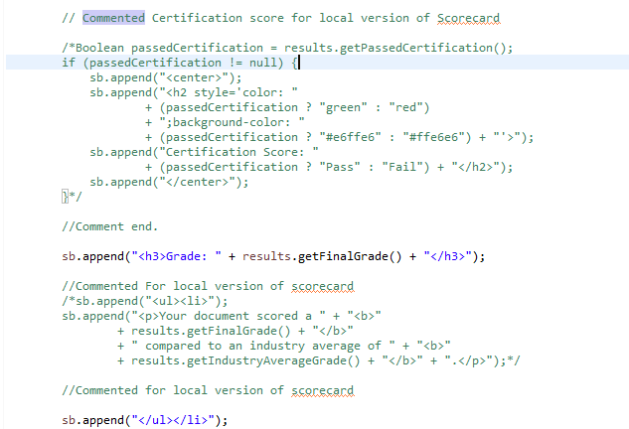

**Step 9**: Comment line number 94 in SiteUploadController.js to disable reference validator call.

**Step 10**: Commented below mentioned sections in topLevelResults.html to remove certification results inforamtion and score card statistics inforamtion.

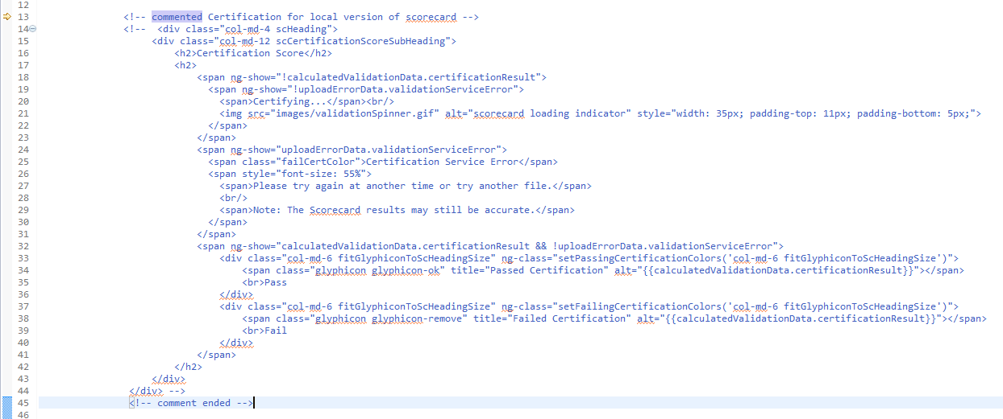

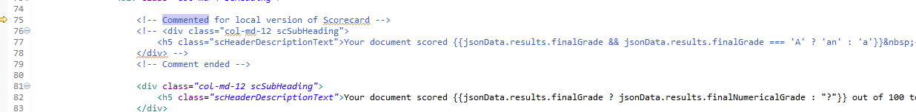

**Step 11:** Build the application, copy war file to tomcat WEBAPPS folder.

**Step 12:** Start tomcat server, use [http://localhost:<tomcat](http://localhost:%3ctomcat) port number>/scorecard URL to access CCDA scorecard application.